BEFORE PRINTING

You must remove the outlines before printing. Here is how to do it:

For PC:

- Go to “File” menu and select “Options”.
- Go to “Display” tab.
- Go to “Printing Options” section and just check “Print drawings created in Word”.
- Go to “Advanced” tab.
- Go to “Show Document Content” section.
- Check “Show drawings and textboxes on screen” and “Show text boundaries”.
- Uncheck “Show picture placeholders”.
- Click “Ok”.
- Type your text in all textboxes. (Please select each box separately to type or copy your text)
- Hold down “Shift” and click on template as you see small filled circles all around the selection like this: 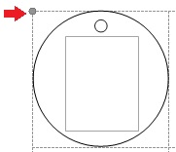

- Right click and select “Format Autoshape/Picture” from the dropped menu.
- Under “Lines” section, select “No Color” from “Color” dropdown list.
- Print your labels.

For Mac:

- Type your text in all textboxes. (Please select each box separately to type or copy your text)
- Hold down “Shift” and click on template as you see small filled circles all around the selection like this: 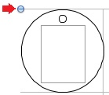

- Right click and select “Format Shape” from the dropped menu.
- In opened “Format Shape” window, 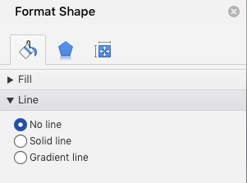 , select “No Line” from “Line” section.
- Print your labels.

